Results of solution performance analysis

DSL-StrongPasswordData.csv:

Unigram:  
SVC method:  
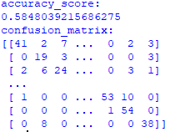

Logistic regression method:

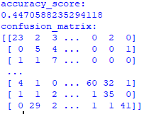

Random Forest method:

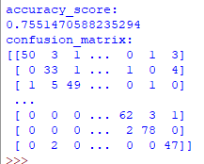

Dataset.csv:

Unigram:  
SVC method:

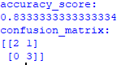

Logistic regression method:

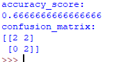

Random Forest method:

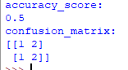

Тест Колмогорова-Смирнова:  
C:\Users\08041\Desktop\схема\QIP Shot - Screen 2085.png